Warren Quattrocchi
CSC 138- section 3
Lab 3 - TCP

- What is the IP address and TCP port number used by the client computer (source) that is transferring the file to gaia.cs.umass.edu? To answer this question, it’s probably easiest to select an HTTP message and explore the details of the TCP packet used to carry this HTTP message, using the “details of the selected packet header window” (refer to Figure 2 in the “Getting Started with Wireshark” Lab if you’re uncertain about the Wireshark windows.
IP address: 192.168.0.14
Port: 63285
- 2. What is the IP address of gaia.cs.umass.edu? On what port number is it sending and receiving TCP segments for this connection?
IP address: 128.119.245.12
Port: 80
3. What is the IP address and TCP port number used by your client computer (source) to transfer the file to gaia.cs.umass.edu?
IP address: 192.168.0.14
Port: 63285

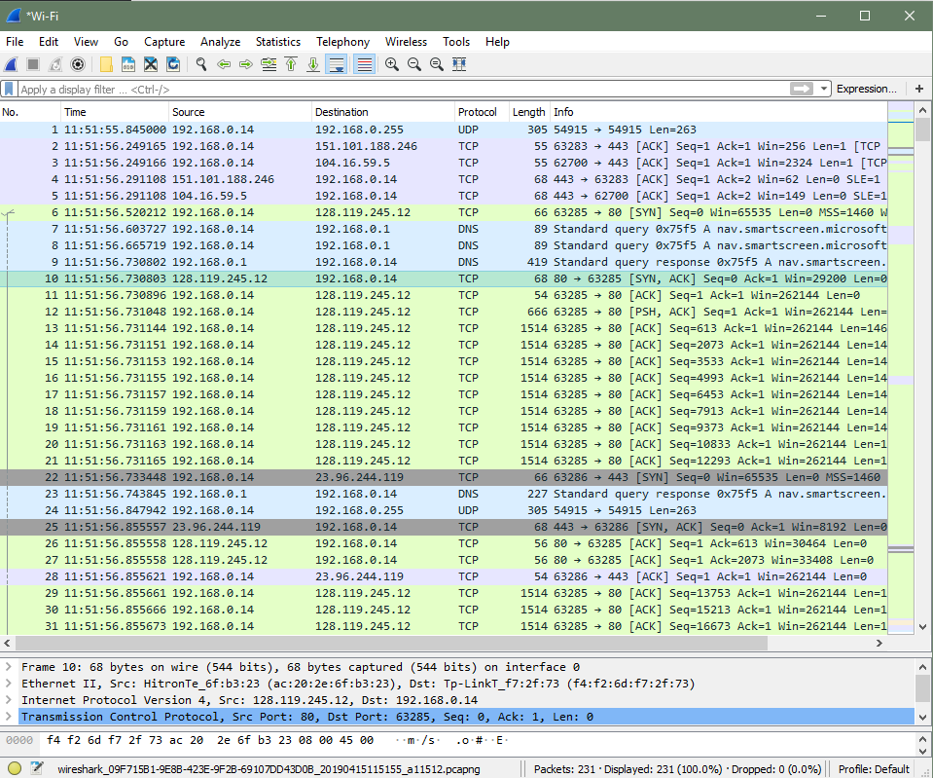
- TCP Basics
    - What is the sequence number of the TCP SYN segment that is used to initiate the TCP connection between the client computer and gaia.cs.umass.edu? What is it in the segment that identifies the segment as a SYN segment?
Seq = 0, it is identified by the [SYN] flag before the sequence number
    - What is the sequence number of the SYNACK segment sent by gaia.cs.umass.edu to the client computer in reply to the SYN? What is the value of the Acknowledgement field in the SYNACK segment? How did gaia.cs.umass.edu determine that value? What is it in the segment that identifies the segment as a SYNACK segment?
Seq = 0, Ack = 1, the Ack is determined by adding 1 to the Seq # of the original SYN segment. The [SYN, ACK] flags identify the segment as a SYNACK segment
    - What is the sequence number of the TCP segment containing the HTTP POST command? Note that in order to find the POST command, you’ll need to dig into the packet content field at the bottom of the Wireshark window, looking for a segment with a “POST” within its DATA field.
Seq = 1
    - Consider the TCP segment containing the HTTP POST as the first segment in the TCP connection. What are the sequence numbers of the first six segments in the TCP connection (including the segment containing the HTTP POST)? At what time was each segment sent? When was the ACK for each segment received? Given the difference between when each TCP segment was sent, and when its acknowledgement was received, what is the RTT value for each of the six segments? What is the EstimatedRTT value (see Section 3.5.3, page 239 in text) after the receipt of each ACK? Assume that the value of the EstimatedRTT is equal to the measured RTT for the first segment, and then is computed using the EstimatedRTT equation on page 239 for all subsequent segments.
Seq = 1 sent at 11:51:56:731048 Ack received at 11:51:56:855558
Seq = 613 sent at 11:51:56:731144 Ack received at 11:51:56:855558
Seq = 2073 sent at 11:51:56:731151 Ack received at 11:51:56:872335
Seq = 3533 sent at 11:51:56:731153 Ack received at 11:51:56:872336
Seq = 4993 sent at 11:51:56:731155 Ack received at 11:51:56:872336
Seq = 6453 sent at 11:51:56:731157 Ack received at 11:51:56:872336
RTT
segment 1: 124.4 ms = 0.124 seconds
segment 2: 124.35 ms = 0.12435 seconds
segment 3: 141.1 ms = 0.1411 seconds
segment 4: 141.4 ms = 0.1414 seconds
segment 5: 141.4 ms = 0.1414 seconds
segment 6: 141.4 ms = 0.1414 seconds
Estimated RTT
segment 1: 0.124 seconds
segment 2: .875 * 0.124 + 0.125 * 0.12435 = 0.12404
segment 3: .875 * 0.12404 + 0.125 * .1411 = 0.12617
segment 4: .875 * 0.12617 + 0.125 * .1414 = 0.12807
segment 5: .875 * 0.12807 + 0.125 * .1414 = 0.12973
segment 6: .875 * 0.12937 + 0.125 * .1414 = 0.13087
8. What is the length of each of the first six TCP segments?
1: 612, 2: 1460, 3: 1460, 4:1460, 5:1460, 6: 1460
    - What is the minimum amount of available buffer space advertised at the received for the entire trace? Does the lack of receiver buffer space ever throttle the sender?
The buffer size is 29200, the sender is not throttled
    - Are there any retransmitted segments in the trace file? What did you check for (in the trace) in order to answer this question?
No, they are none. I checked by looking for duplicate or lower sequence numbers
    - How much data does the receiver typically acknowledge in an ACK? Can you identify cases where the receiver is ACKing every other received segment (see Table 3.2 on page 247 in the text).
1460 bytes
    - What is the throughput (bytes transferred per unit time) for the TCP connection? Explain how you calculated this value.
Start time: 56.520212
end time: 57:290348
770.137 ms total in connection
152,938 bytes sent – last ack received
198.585 bytes/ms

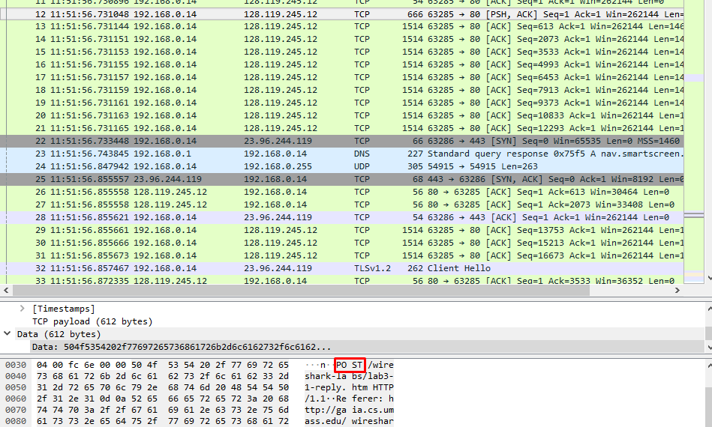

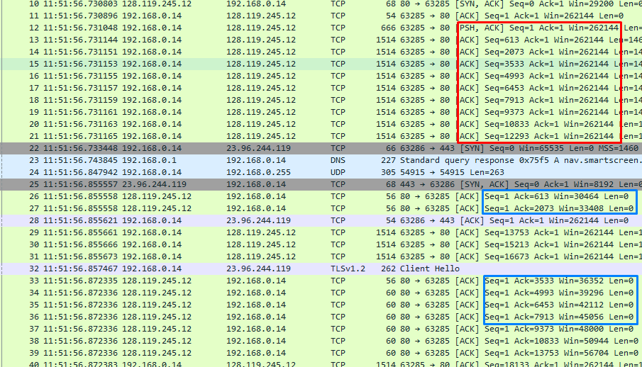

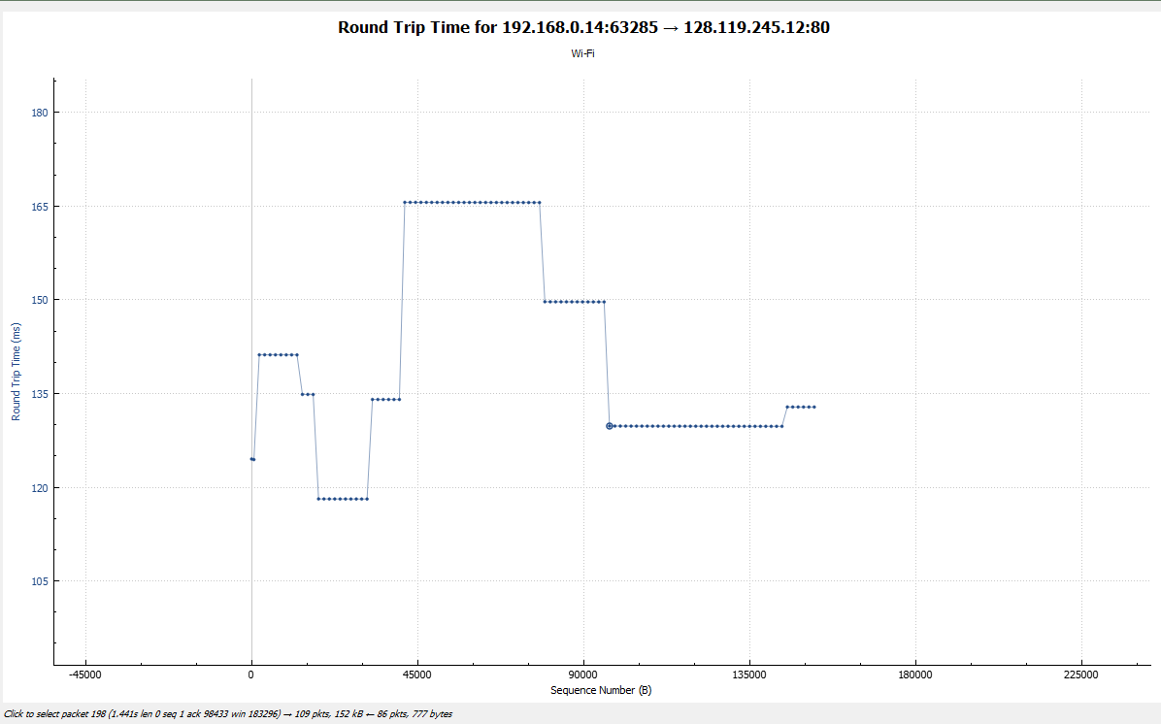
4. TCP congestion control in action
        - Use the Time-Sequence-Graph(Stevens) plotting tool to view the sequence number versus time plot of segments being sent from the client to the gaia.cs.umass.edu server. Can you identify where TCP’s slowstart phase begins and ends, and where congestion avoidance takes over? Comment on ways in which the measured data differs from the idealized behavior of TCP that we’ve studied in the text.
Yes, there are clear increases in speed and plateaus in the graph where it appears congestion control is kicking in to avoid data loss.
The growth in the chart appears very linear, as opposed to the exponential growth discussed during lecture.

